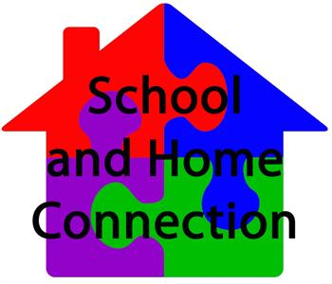

***School-Parent Compact For Student Success***

***2025-2026***

***Revised 8/11/2025***



HHS

is a place of

**H.O.P.E.**

**Chris Nabahe**

Principal

4558 Brothersville Road Hephzibah, Georgia 30815

(706) 592-2089

[nabahch@boe.richmond.k12.ga.us](mailto:nabahch@boe.richmond.k12.ga.us)

***What is a School-Parent Compact?***

It is a written agreement describing how all members of a school community (parents, teachers, principals, and students) agree to share responsibility for student learning. This compact helps build a bridge between the school and home to encourage learning, communication, and achievement for all students.

***Jointly Developed***

Parents, students, and staff collaborated to develop this school-parent compact for achievement. Parents are encouraged to attend annual revision meetings held in the spring each year to review the compact and make suggestions based on student needs and school improvement needs. Parents are also encouraged to participate in the annual Title I parent survey that is also used as a tool to collect parent feedback regarding current Title I programs and policies.

***Activities to Build Partnership***

Hephzibah High School promotes parental engagement through various events and programs such as:

* Training & Volunteering
* Family Workshops
* Curriculum Nights
* Conferences
* College-Career-Resource EXPO

***Communication about Student Learning***

Hephzibah High maintains communication with parents through:

* Infinite Campus
* Remind 101
* Phone Calls/Shout Points
* Phone Calls
* School/Teacher websites
* Parent Conferences
* Progress Reports
* Text Messages and Email
* Parent Facilitator: Mrs. Heard heardte@richmond.k12.ga.us

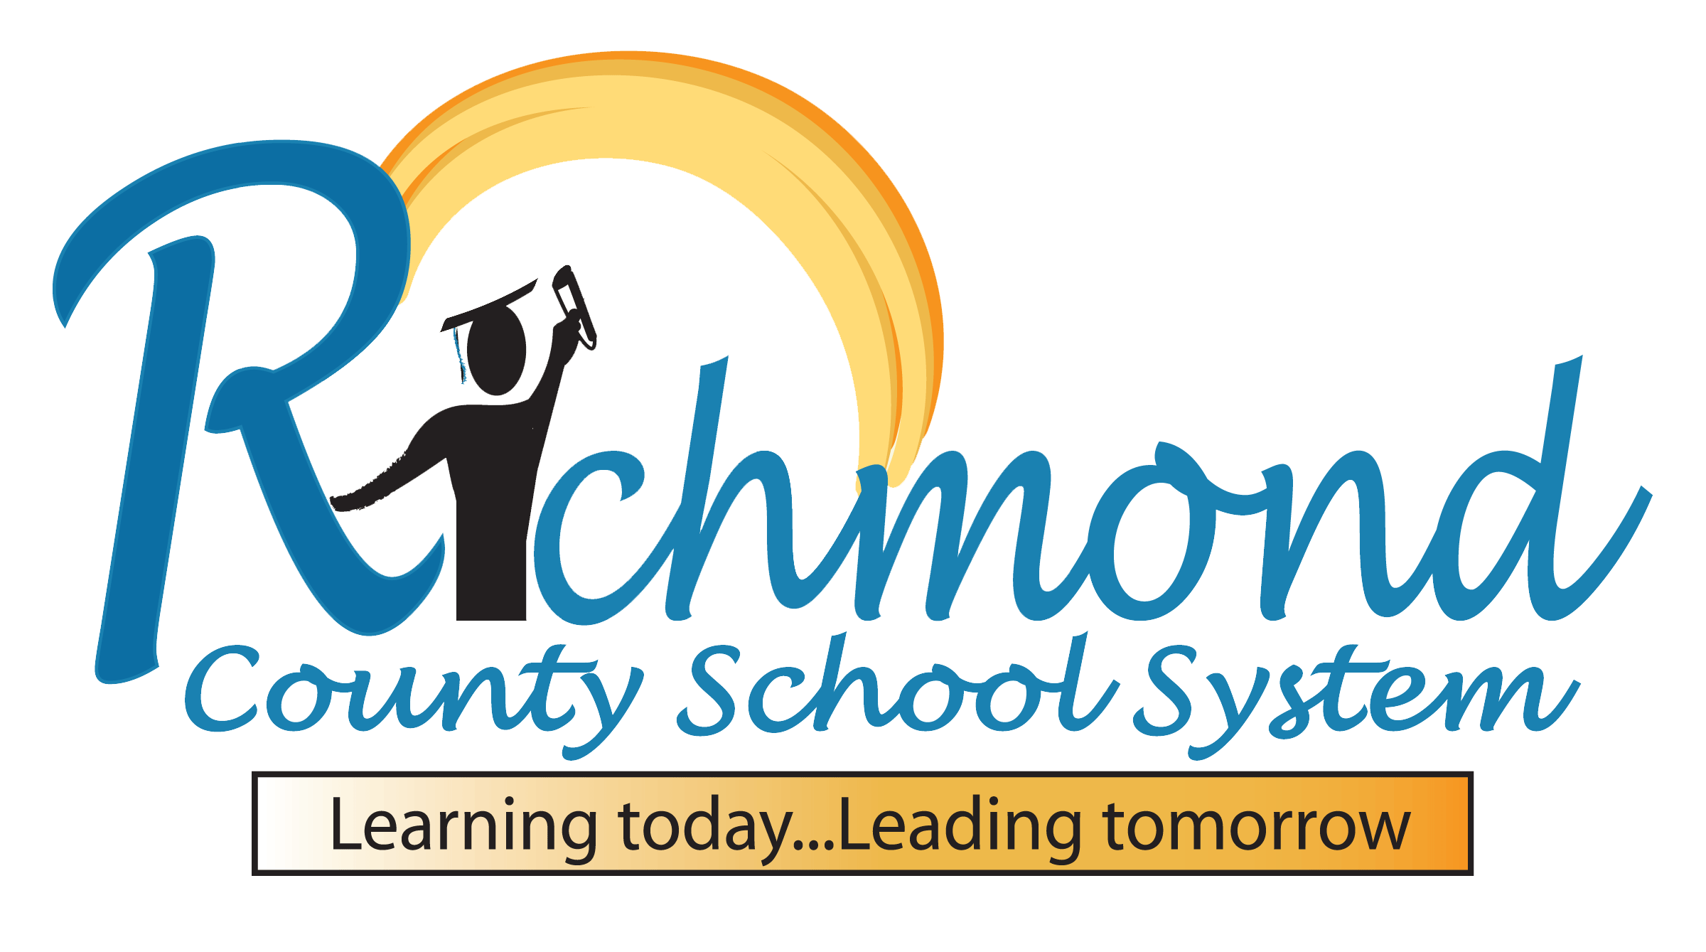

***District Goals***

* During the 25-26 school year, we will increase student content mastery in tested subject areas on the Georgia Milestones by 6%.
* During the 25-26 school year, we will increase post-high school readiness by increasing our graduation rate by 2%.

***School Goals***

* During the 2025-2026 school year, HHS will increase the graduation rate by 3% from, 74.7% to 76.9% by a continued focus on the strategy map and working to produce graduates that meet the Richmond County School System Profile of a Graduate.
* During the 2025-2026 school year, HHS will improve instructional capacity of all teachers by increasing the average e-Walk score (Rigorous Learning Environment) by 25% based on Beginning of Year (BOY) walkthrough (baseline) data.
* During the 2025-2026 school year, HHS will support Digital Learning for all students. 75% of all students will use 1:1 technology to set goals, plan activities, monitor progress, evaluate results, and monitor their academic progress during grade level HR activities via Canvas.

***Focus Areas***

-Vocabulary development, read for fluency and comprehension

-Number sense, fact fluency, multi-step problem solving

***As a student, I will….***

Commit to obtaining and following guidance to get on and/or remain on track to graduate from high school with cohort.

Monitor my progress through accessing Edgenuity, Infinite Campus, I-Ready, and resources to be used at home for personal study time in math, science, social studies as well as other courses as needed.

Discuss with my parents how to seek assistance from guidance counselors, and teacher conferences.

***As a school, we will….***

Provide instruction and guidance to assist students to get on and/or remain on track to graduate with their cohort.

Provide access to Edgenuity, Infinite Campus, iReady, and resources to be used at home for personal study time in math, science, social studies as well as other courses as needed.

Provide varying times for meetings with guidance counselors, and teacher conferences.

***As a parent, I will …***

Keep abreast of school policies and graduation requirements to ensure my child stays on track to excel and graduate with his/her cohort.

Monitor my child’s progress by accessing Edgenuity, Infinite Campus, iReady, and resources to be used at home for personal study time in math, science, social studies as well as other courses as needed.

Seek assistance from guidance counselors, and teacher conferences.

***Teachers, Parents, and Students—Together for Success***